Abstract
This project proposes an "City Walk Route Guide" designed for young tourists with limited leisure time who focus on short trips, enjoy city landscapes and entertainment consumption. The project will initially focus on five famous "city walk" streets in Shanghai: Yu Garden Road, Anfu Road, Wukang Road, People's Square and Huaihai Road. By organizing multiple visual data such as photos, descriptions, and social media comments (covering service attitude, price range, etc.) on interactive Google Maps (as shown in Fig.1), it provides users with more referenceability to explore cities and enjoy short vacations, avoiding the unpleasant experience of wasting limited time on uninterested tourist attractions. As a tool for developing multi-dimensional information and assisting urban exploration, this project will promote public awareness and reflection on "internet celebrity culture" and consumerism from multiple perspectives, cater to the consumption and travel habits of contemporary young people, and provide an example of information visualization for the tourism industry in other regions.
Fig. 1 Overview of the Map
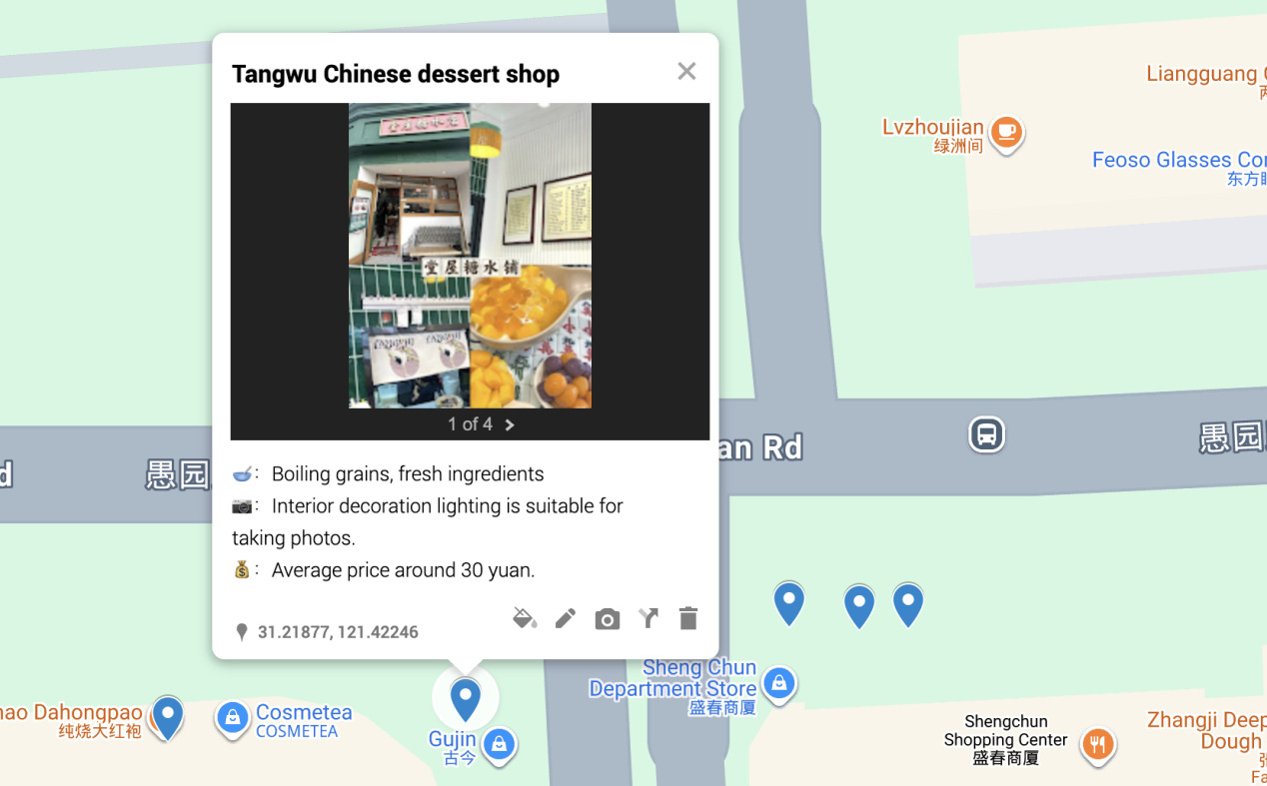

Value — Community-Based Learning & Social Impact
2.1 Targeted Community
Our visualization project mainly serves young tourists and residents in Shanghai who have limited leisure time and focus on budget. This group is the most active participant and subject in the city's "internet celebrity" consumer culture, relying on social media to explore travel destinations. However, they are now facing serious information asymmetry, often encountering disappointing experiences such as idealized online performance and high prices (such as 50 yuan per cup of coffee), overly commercialized spaces, and real-life scenes that are completely different from social media images. Our project enables this community to break through the dilemma of information asymmetry, develop urban landscape tours through multidimensional information, and make full use of limited rest time and financial resources.
2.2 Community based learning connections
Our project has a different emphasis on viewing content compared to field trips. The Jiading Urban Planning Exhibition Hall showcases the top-down, data-driven urban development process and future vision, which is an official narrative presentation of data. In contrast, our project uses data visualization to build a bottom-up, ordinary citizen based city and develop a commenting function in the next step of development, listening to the voices of the public and providing tourists with more comprehensive experience explanations and information, rather than building consensus and using a single defined tool.
At the same time, our personal experience of being deceived by online information and our visual journey in the Fengxian Science and Technology Museum have made us deeply aware that the social media filters and carefully designed internet celebrity spaces are essentially a commercial driven "daily science fiction", with the ultimate goal of shaping consumer desires. Our project utilizes visualization technology to conduct a "demystification" practice, helping users penetrate the consumer fantasy woven by algorithms and capital, and touch on a more grounded experiential reality. Therefore, our map integrates these insights and uses data visualization technology to critically reveal the "deceptive" internet celebrity tourism economy, while also providing comprehensive information for young tourists with corresponding needs, so that they can weigh the pros and cons and make better tourism route planning with abundant information.
2.3 Applied Learning & Critical Reflection
This project serves as an applied learning tool that directly addresses two key, interrelated urban challenges identified in contemporary research. It is explicitly designed around the critical reflection cycle—experience, analysis, abstraction, and application—which is fundamental to deepening learning in community-based contexts [4]. And it will transform them into practical resources for community self-protection and sustainable consumption.
Firstly, our project will implement the key findings of Jakarta M BLOC spatial research. This study suggests that the aesthetic of "installable programs" is not an organic cultural trend, but a thoughtful business strategy aimed at redesigning spaces to maximize foot traffic and revenue [1]. There is a direct negative inference in the consumption pattern of Shanghai: it promotes both homogenization (streets crowded with visual similarity and theme driven bakeries and cafes) and deceptive marketing (a large number of edited photos masking mediocre reality). These two issues stem from the same business logic, directly leading to consumer failure - wasting time, money, and emotional disappointment. Our map addresses this issue by crowdsourcing and visualizing the gap between business planning images and life experiences, enabling users to see through strategies and make informed choices.

Secondly, our methodology is inspired by the practicality of architectural level spatial analysis in Hong Kong [3]. Like Hong Kong, Shanghai is a high-density mega city with extremely scarce and expensive land resources. This economic pressure exacerbates the above-mentioned problems, as businesses face high rents that are often passed on to consumers at inflated prices. In this situation, simply identifying the 'bad' points is not enough; We must promote the effective utilization of existing urban structures. Therefore, by highlighting regions and companies that provide true value, authenticity, and fair pricing, we guide users to make reasonable choices. It will also promote the sustainable development of urban consumer culture, consistent with broader goals such as promoting a healthy "single economy" (where individuals are self-centered and make satisfying purchases), and advancing Sustainable Development Goal 11 by promoting community led and resource conscious urban participation.
By linking the diagnosis of the problem (based on a case from Jakarta) with the method of finding solutions (adapted from the Hong Kong approach), our project has created a critical cycle of reflection. It moves users from passive consumption to active civic understanding, embodying the goal of applied learning to foster critical thinking and empowered community participation [2]. It transforms users from passive urban spatial consumption to active and analytical understanding of their economic and social forces, ultimately forming more powerful and sustainable consumption behaviors.

Data Sources & Data Governance
3.1 Data source
To ensure the depth and reliability of the project initiation phase, our data work will be divided into two clear stages:
- Core data (manually collected and annotated by designers): This is the cornerstone of the initial version of the project. The team will implement a systematic manual data collection process for stores along the five target routes:
- Source filtering: Focus on the Xiaohongshu platform, strictly screen sharing posts from real users, and exclude official marketing content from merchants.
- Content analysis: For each store, we will analyze about 20 posts with the highest relevance, manually read and summarize them, extract and structure the following key information:
Store attributes: type (such as bakery, second-hand shop), core selling points.
Space assessment: decoration style and potential for "production", seating availability, and regular queue time.
Consumption level: Summarize the per capita price range of food or goods based on post information.
- Data entry: This set of manually validated structured information will form a high reliability initial data layer for interactive maps, providing users with a solid reference foundation.
- Future expansion (user crowdsourcing): After receiving feedback on the project prototype, we plan to develop simple user contribution features to achieve sustainable data updates.
User submission: Users can submit tags (such as "inflated price", "authentic experience") and brief comments.
Data augmentation: This stage will transform the map from a static guide to a dynamic community resource.
- Data governance
We promise to build this community resource with a transparent and responsible attitude.
- Transparency and traceability: All data points will be clearly labeled with their source ("team editing" or "user contribution") and date. We will explain how data is collected and processed.
- Privacy Protection: During the manual collection phase, we only analyze and reference non personal information that has been publicly disclosed on social media. The content contributed by future users will be completely anonymized.
- Quality and Fairness (Simplified Version): The quality of initial data is ensured through systematic manual review by the design team. In the future, we will establish basic community tagging and team review mechanisms for user contributed data to maintain the constructive nature of the information. We will establish community guidelines to clarify that the project aims to provide authentic consumer insights to promote rational choices.

REFERENCES

[1] R. D. Aprilian and I. Widiastuti, “The story of adaptive reuse in Jakarta’s old building under the ‘instagrammable’ era,” in *Proc. 8th Biannual Int. Conf. ARTEPOLIS (ARTEPOLIS 2020)*, Bandung, Indonesia (Online), 2021. [Online]. Available: https://doi.org/10.2991/assehr.k.211126.019

[2] T. L. Trolian and E. A. Jach, “Applied learning in higher education: Conclusions and recommendations for institutional leadership,” *New Directions for Higher Education*, vol. 2019, no. 188, pp. 101–106, 2019.

[3] A. Maheshwari, Y. Jain, and S. S. Chopra, “Spatial inequity index for essential facility access at building-level in highly dense urban areas,” *Cities*, vol. 149, p. 104926, Jul. 2024. [Online]. Available: https://doi.org/10.1016/j.cities.2024.104926

[4] S. L. Ash and P. H. Clayton, “Generating, deepening, and documenting learning: The power of critical reflection in applied learning,” *Journal of Applied Learning in Higher Education*, vol. 1, pp. 25–48, Fall 2009.

